SIMULATION RESULTS

There is an R load in the simulations. 80 W is intended. Therefore;

P=V2/R

P=80W,

V=48 V,

R=28.8V

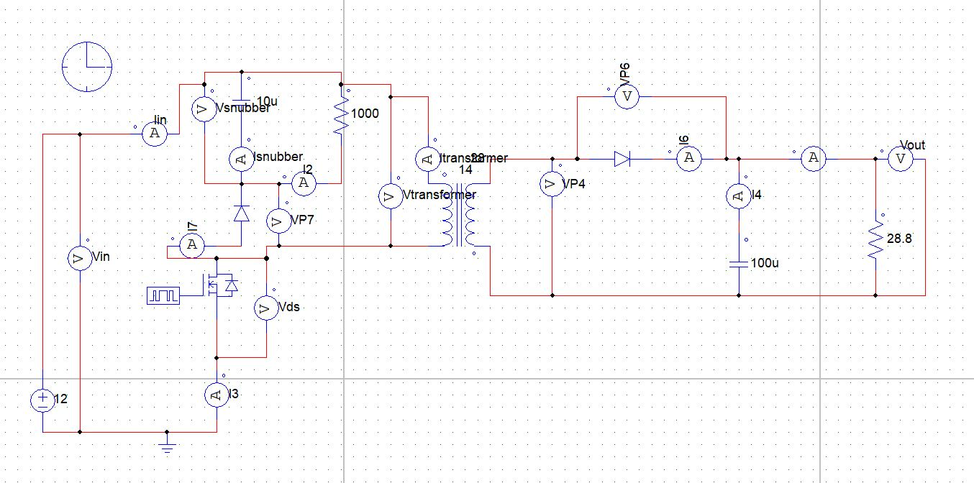

Figure : Circuit Schematic for 12V -48V Flyback Converter (Without Gate Driver)

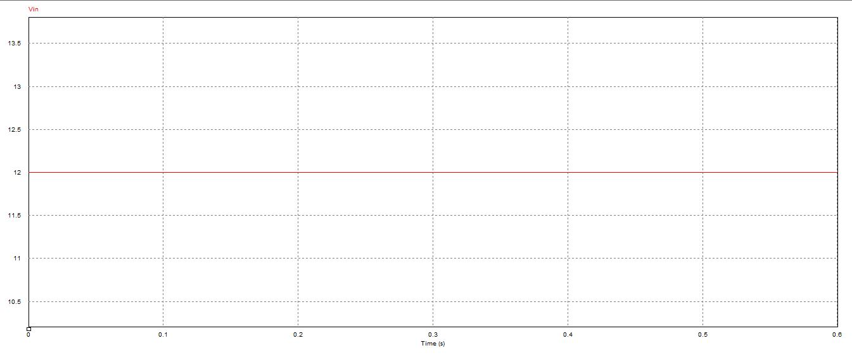

Figure : Input Voltage Waveform

In this project 12V input voltage is converted to 48 V output voltage by using Flyback converter and input voltage is 12V as shown in Figure .

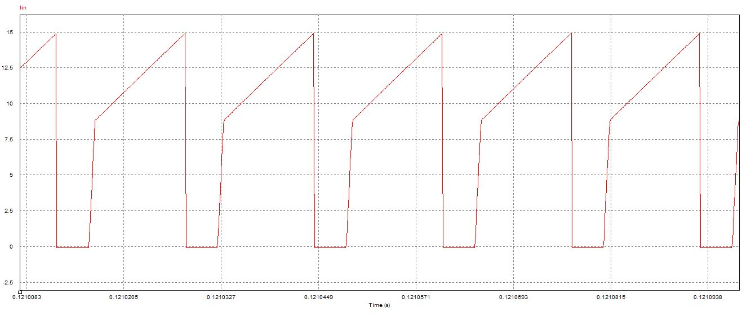

Figure : Input Current Waveform

Input waveform is shown in Figure . This characteristic is expected. Slope of the voltage depends on Lm and there is not a saturation so Lm characteristic is sharp. In addition, continuous conduction mode is observed. Mean current is nearly 80/12=6.67 V.

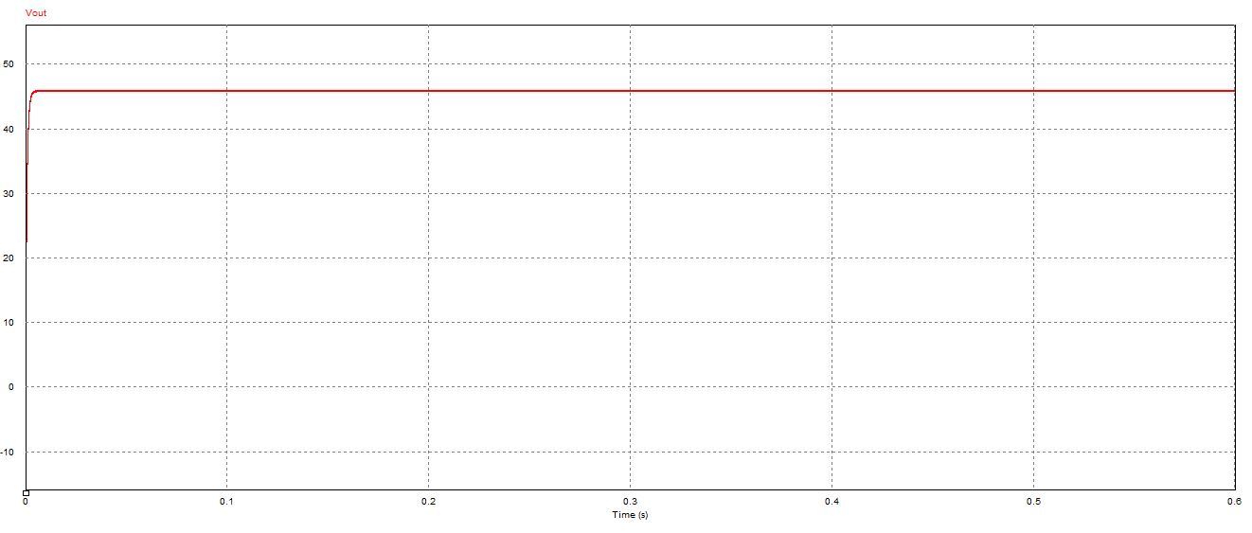

Figure : Output Voltage Waveform

Output voltage is nearly 48 V as shown in Figure .

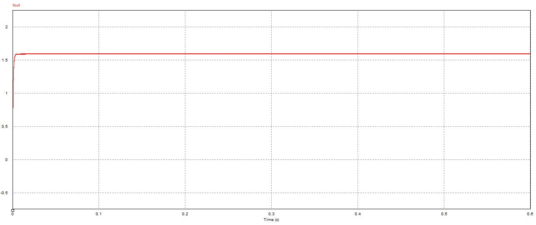

Figure : Output Current Waveform

Output current waveform is observed in Figure . Mean value is nearly 1.67 V.

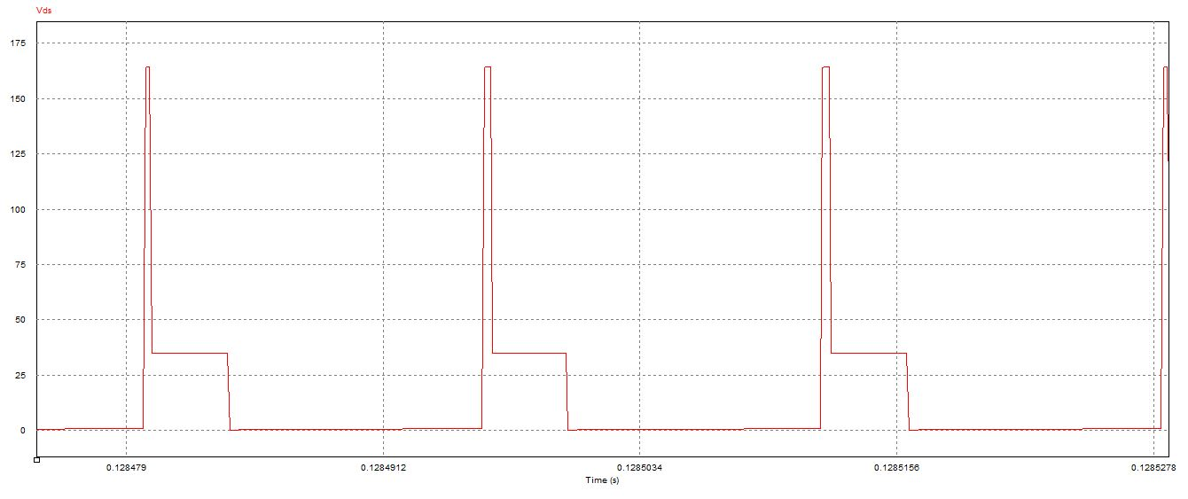

Figure: Vds (Drain- Source Voltage) of the MOSFET

Drain to source voltage is shown in Figure . Spikes are crucial for MOSFET selection and this peak values are intended to decrease by using snubber. Theoretically, nearly 170 V peak value is observed so at least a MOSFET which has 200 V drain to source value should be selected.

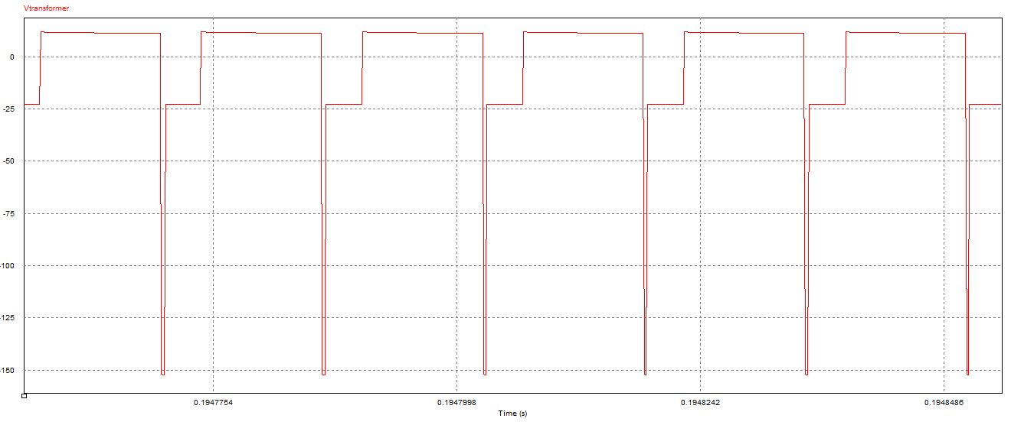

Figure : Transformer Voltage Waveform

Transformer voltage characteristic is shown in Figure . If the transformer was ideal; that is, if there was not a leakage inductance, negative spikes would not be observed; however, practically this spikes are observed and snubber design has an importance in order to use transformer effectively.

$V=Ldi/dt$

Negative spikes are observed due to the instantaneous current changes at the switching instants.

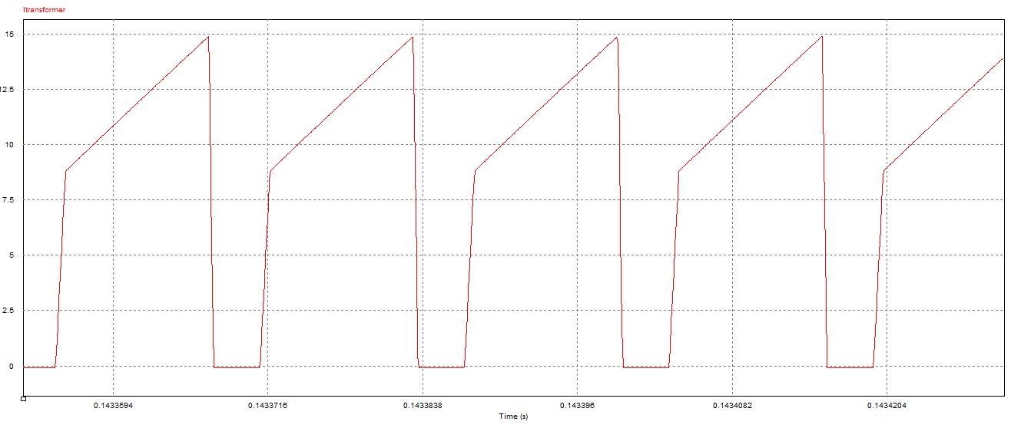

Figure : Transformer Current Waveform

Transformer current waveform characteristic is the same as input current characteristic as expected. Lm is an affective factor for the slope of the voltage characteristic. Saturation is not observed.

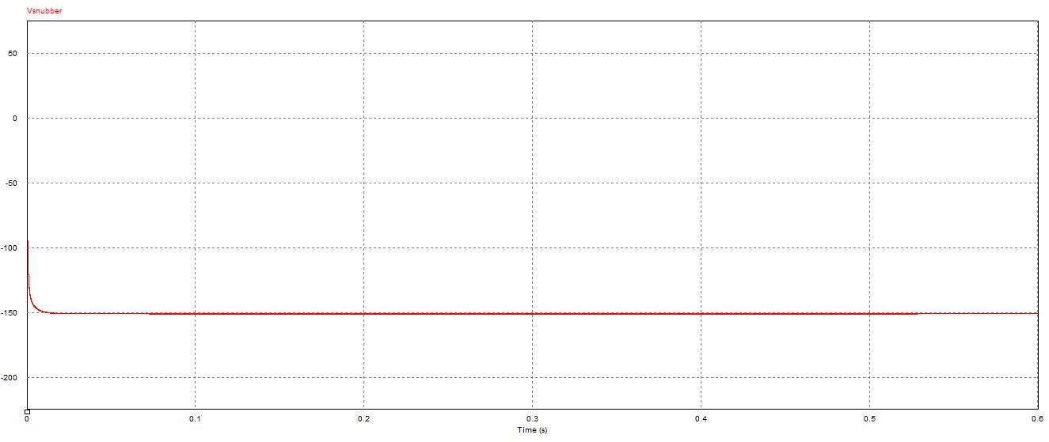

Figure : Snubber Voltage Waveform

Snubber Voltage waveform is observed as shown in Figure . Nearly 150 V is kept from the snubber so drain to source voltage of the MOSFET is decreased by using snubber. Snubber design and MOSFET selection have a relation each other. If there was not a snubber, Vds of the MOSFET would be very high and selected MOSFET should be changed.

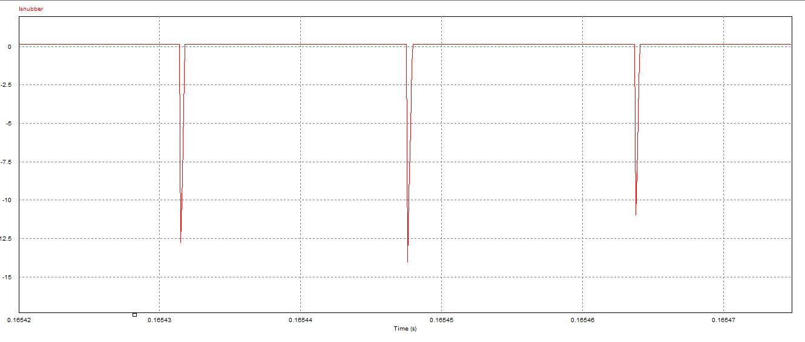

Figure : Snubber Resistor Current Waveform

Snubber current is shown in Figure . There is negative instant currents at the switching instants due to the leakage inductance.

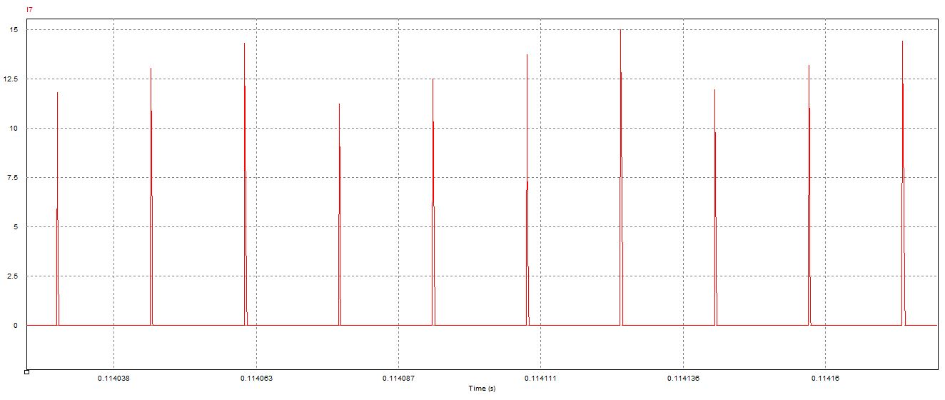

Figure : Snubber Diode Current Waveform

Initially, 27 A instant current is observed over the snubber diode. After that, current arrives nearly 15 V at switching instants. Therefore, two diodes are tied parallel in order to achieve 40 A capacity.

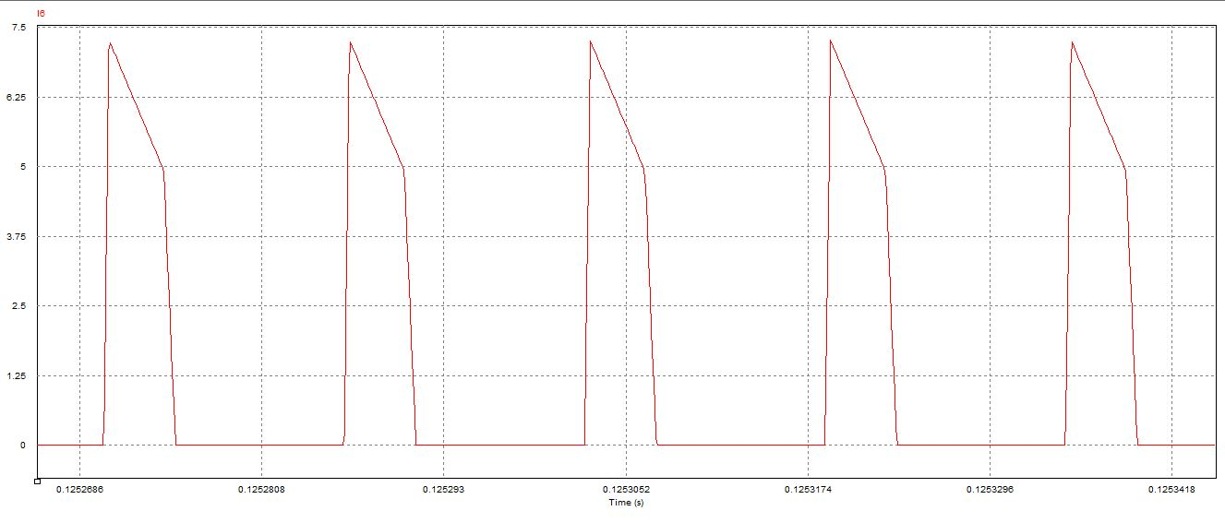

Figure : Output Side Schottky Current Waveform

Initially 13 A instant current is observed over the output diode. At the steady state diode current achieve 7.5 A. We selected a schottky diode which has 15 A current capacity. We selected schottky type capacitor because it keeps low voltage; that is on voltage is low for schottky diodes and output voltage affects lower by using schottky diode.

TEST RESULTS

